Project Design Phase-II
Data Flow Diagram & User Stories

Date | 31 January 2025
Team ID
Project Name
Maximum Marks | 4 Marks

Data Flow Diagrams:
A Data Flow Diagram (DFD) is a traditional visual representation of the information flows within a system. A neat and clear DFD can depict the right amount of the system requirement graphically. It shows how data enters and leaves the system, what changes the information, and where data is stored.
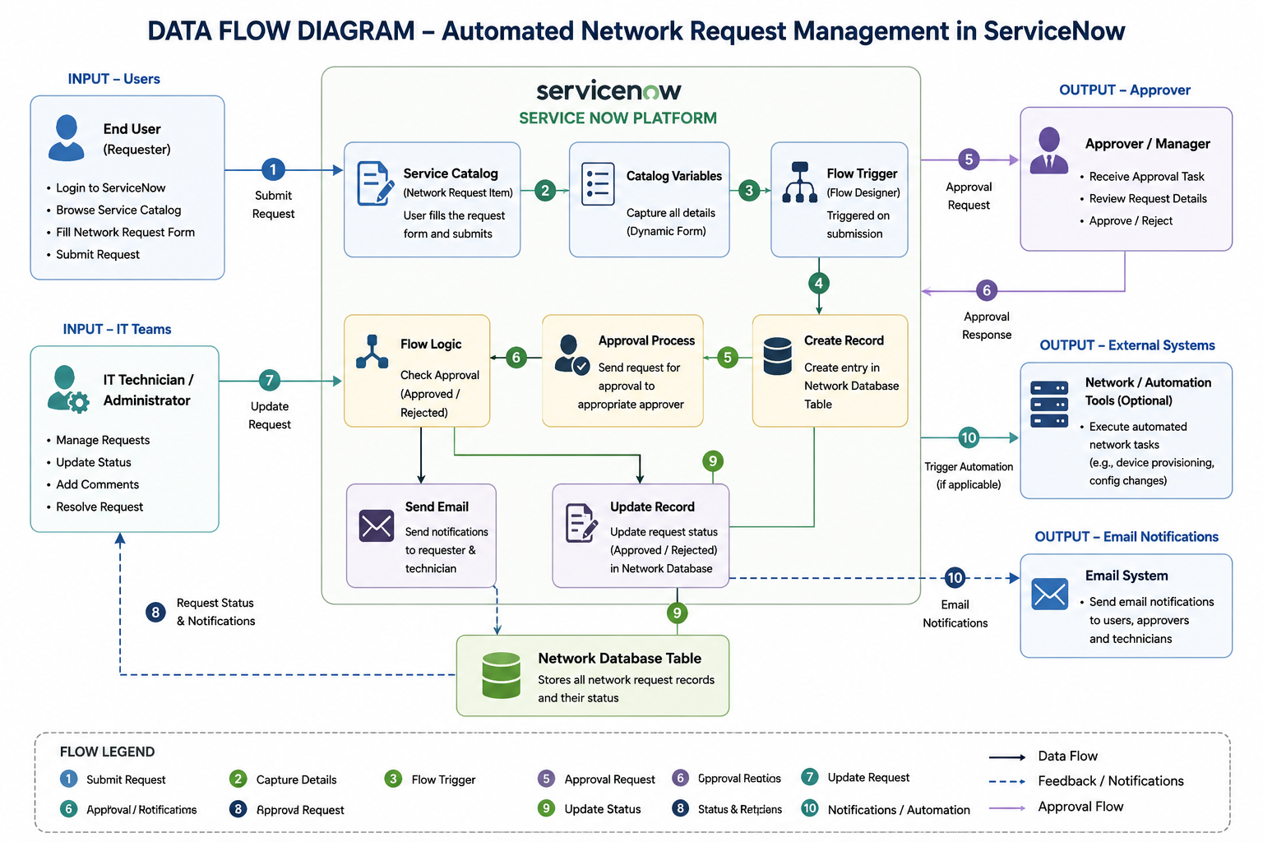

User Stories :
USN-1: As a user, I can submit a network request through the Service Catalog.
USN-2: As a user, I can provide all required network request details before submitting the request.
USN-3: As a user, I can upload supporting documents with my network request.
USN-4: As a user, I can view dynamic form fields based on the selected request type or device type.
USN-5: As a user, I can track the status of my submitted network request.
USN-6: As a user, I can receive email notifications about my request status.
USN-7: As an IT technician, I can view assigned network requests for processing.
USN-8: As an IT technician, I can update the progress and status of assigned requests.
USN-9: As an IT technician, I can add work notes and resolve network requests.
USN-10: As an approver, I can approve or reject submitted network requests.
USN-11: As an approver, I can provide comments while approving or rejecting a request.
USN-12: As an administrator, I can create and manage Network Request catalog items.
USN-13: As an administrator, I can configure catalog variables and variable sets.
USN-14: As an administrator, I can configure Catalog UI Policies for dynamic forms.
USN-15: As an administrator, I can automate the request process using Flow Designer.
USN-16: As an administrator, I can create and maintain the Network Database table.
USN-17: As an administrator, I can configure automated email notifications.
USN-18: As an administrator, I can generate reports and monitor request performance.

